3GPP TSG RAN WG1 #125 R1-2604405
Dalian, China, May. 18th ~ 22nd, 2026
Agenda Item: 10.8.2
Source: HONOR
Title: Study on aspects of integration with communication for ISAC
Document for: Discussion and Decision

Introduction
According to the ITU-R recommendations, ISAC as a new usage scenario, is regarded as a crucial element for 6G radio, which are designed to improve communication and serve as a fundamental infrastructure to enable new user and application trends [1]. In RAN#110 meeting, a revised SID for 6G radio has been approved with the following objectives for sensing [2].
The detailed objectives of the study are:
......
- Sensing – Studies to be based on use cases and associated requirements, as defined in [TR38.914]
- PHY functions and procedures for sensing technology (e.g., waveform. reference signals, measurement feedback, etc…) [RAN1, RAN4]
- Evaluate sensing performance and if necessary, extend channel modelling, for the selected use cases [RAN1]
- Aspects of integration with communication services [RAN1]
- higher layer procedures and protocol aspects [RAN2]
- RAN4 aspects of sensing including RF, coexistence, and testability in coordination with other WGs [RAN4]
Note: RAN1 identify detailed requirements, if triggered by TSG RAN
In this contribution, we discuss potential issues on aspects of integration with communication for ISAC.

Sensing modes
The study by SA2 has captured the following key issue for ISAC in TR 23.801-01 [3],
Study the integration of Sensing and Communication over 3GPP access, covering RAN node and UE operating as 3GPP Sensing Entities in the different sensing modes in alignment with TSG RAN, and considering multiple sources of sensing data.
The following aspects will be studied:
- Architecture and functional support for Sensing Service, including:
- Sensing Service authorization and revocation.
- Discovery and (re-)selection of Sensing function and Sensing Entities (i.e. RAN nodes, UEs), including sensing modes selection.
- Configuration parameters and policy provisioning to support sensing service, e.g. to the selected Sensing Entities, Sensing function, etc.
- Collection and transport of 3GPP sensing related data for sensing result generation.
- Exposure framework of sensing result to the Sensing service consumer (i.e. AFs, UEs, Core NFs).
......
which indicates that in addition to RAN nodes, UEs may also participate in the sensing process as sensing entities. Usually, sensing operation can be implemented in two different ways, from radar-like sensing where the sensing transmitter and sensing receiver are co-located in the same entity, called monostatic sensing, to having the sensing receiver and sensing transmitter in different entities, called bistatic sensing. Therefore, at least six sensing modes as shown in Fig. 1 could be considered in 6G radio.
Proposal 1: At least six sensing modes of TRP monostatic, TRP-TRP bistatic, TRP-UE bistatic, UE monostatic, UE-UE bistatic, and UE-TRP bistatic could be considered in 6G radio.
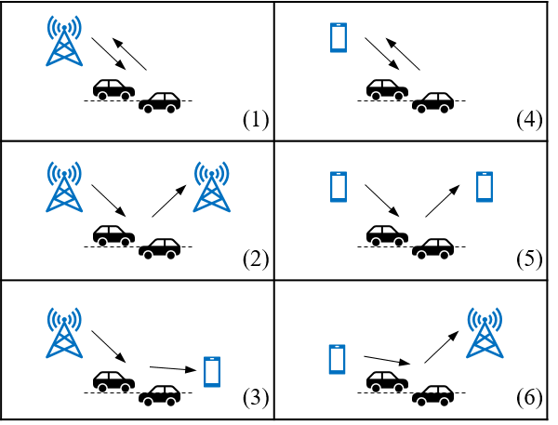
Fig. 1 Different sensing modes with RAN node and UE operating as sensing entities. (1) TRP monostatic, (2) TRP-TRP bistatic, (3) TRP-UE bistatic, (4) UE monostatic, (5) UE-UE bistatic, (6) UE-TRP bistatic.
A 6G UE may support multiple sensing modes simultaneously. Different sensing models provide different sensing accuracy. In addition, different UEs may have different sensing capabilities and sensing requirements. To achieve the required sensing accuracy, different sensing measurement procedures may be selected, e.g. selecting one of the aforementioned six sensing modes.
Proposal 2: Study sensing measurement procedures, from RAN1 perspective, under different sensing modes and UE capabilities.

Reference signal

RS requirements
In TR 22.870, up to 25 use cases for 6G ISAC have been identified, such as environment object reconstruction, road digitalisation, etc., and use cases where sensing capabilities are used to trigger or support subsequent actions are also captured [4]. For each use case, it provides the corresponding KPIs that 6G system shall be able to support, and the involved KPIs include confidence level, accuracy of positioning/ velocity estimate, sensing resolution, max sensing service latency, refreshing rate, missed detection probability, and false alarm probability.
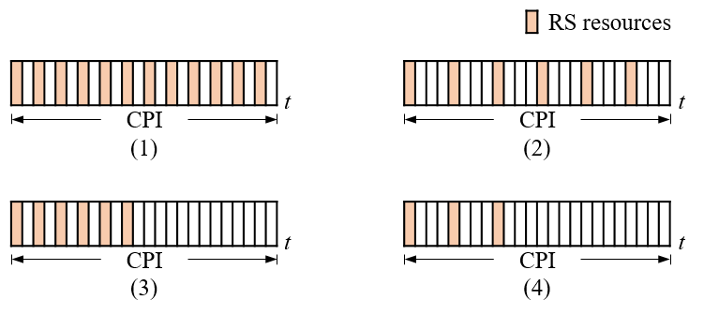
Fig. 2 Different RS resource occupations within a CPI in time domain correspond to different sensing performance of maximum unambiguous doppler shift $f_{d}^{max}$ and doppler shift resolution $f_{d}^{r}$. (1) $f_{d}^{max1}$ and $f_{d}^{r1}$, (2) $f_{d}^{max2}$ and $f_{d}^{r1}$, (3) $f_{d}^{max1}$ and $f_{d}^{r2}$, (4) $f_{d}^{max2}$ and $f_{d}^{r2}$.
From RAN1’s perspective, values that the above KPIs can reach are not only related to the sensing processing algorithm, but more importantly, also to the design of the RS for sensing, including the sequence type used for producing the signal, power allocation, and the density and width of the occupied physical resources in time, frequency, and spatial domains. For instance, as shown in Fig. 2, different RS resource occupation manners within a CPI in time domain correspond to different sensing performance of maximum unambiguous doppler shift and doppler shift resolution, and these two performance metrics affect velocity-related KPIs.
Each use case is associated with its own KPI requirements, and hence the requirements on RS design may vary for different use cases. For a given use case, the introduction of enhanced RS for sensing depends on whether the sensing KPI of that use case can be fulfilled by the RS design for communication.
Proposal 3: For a given use case, the introduction of enhanced RS for sensing depends on whether the sensing KPI of that use case can be fulfilled by the RS design for communication.

RS patterns
In RAN1#124bis meeting, the following agreement was captured [5].
Agreement:
- Study RE patterns of RS for sensing, considering sensing performance, resource overhead and impact to communication
- Note: enhancements on RS sequence if any will be discussed in agenda 10.8.3
In order to achieve high-resolution and unambiguous sensing for velocity, a long observation duration and dense time-domain RS are required, e.g. M RS symbols within a CPI. Similarly, to achieve high-resolution and unambiguous sensing for range, large bandwidth and dense frequency-domain RS are required, e.g. N REs. When sensing for both range and velocity are required, a uniform RS pattern across time and frequency may lead to a significantly large sensing resource overhead, i.e. on the order of M*N REs. In practical sensing scenarios, the Delay-Doppler space is typically sparse, and the number of sensing targets presented simultaneously is usually much smaller than M*N. According to the compressed sensing theory, when sensing targets exhibit sparsity in a certain domain (e.g. Delay-Doppler domain), it is possible to perform sampling at a rate lower than the Nyquist rate, while still enabling near-perfect reconstruction of the original signal. This indicates that non-uniform RS pattern can achieve sensing performance comparable to that of uniform counterpart, while significantly reducing the sensing resource overhead.
Non-uniform RS can be realized by combining multiple uniform RS resources, thereby avoiding the workload for complex RS pattern designs. The “combining” concept already exists in NR, where TRS is formed by combining 4 uniform RS resources into one RS resource set. For sensing purposes, a similar approach can be considered, where multiple RS resources are aggregated to form a sensing RS resource set. In addition, the constraints applied in TRS could be relaxed, e.g. the number of RS resources participating in the aggregation may not be limited to 4, and the RE locations of each aggregated resource may be different.
Proposal 4: Support non-uniform RS resource, and it can be considered that non-uniform RS resource is constructed by aggregating multiple uniform RS resources.
To ensure the performance of compressed sensing, an appropriate sparse basis needs to be selected for the under-sampled measurements. Considering the diversity of sensing scenarios, the flexibility of the sparse basis should be guaranteed. This, in turn, imposes requirements on the flexibility of the aggregated non-uniform RS resources. Therefore, when designing RS resource, the requirements of non-uniform RS aggregation can be considered.
Proposal 5: When designing RS resource, the requirements of non-uniform RS aggregation can be considered.

RS bundling
In RAN1#124bis meeting, the following issue was discussed but no agreement has been reached [6].

[FL1][H] Proposal 4.4-1-rev1
- On phase continuity for DL/UL sensing RS, study at least the following aspects.
  - Aspects to maintain phase continuity in a CPI
  - Events causing phase discontinuity, e.g., TDD UL/DL switch, change of power/TA, etc.
  - Whether/how to recover phase continuity?
  - Other aspects are not precluded
To enable the sensing receiver to perform time-domain coherent processing on the received RS and thereby extract velocity information, it is important for the sensing transmitter to ensure power consistency and phase continuity of the transmitted RS within the CPI.
For UL sensing RS, when considering power consistency and phase continuity, the design of DM-RS bundling for PUSCH/PUCCH in NR can be referenced. A bundling TDW for sensing RS can be introduced, and UE shall maintain power consistency and phase continuity within an actual bundling TDW across sensing RS transmissions. The determination of the actual TDW may take the following factors into account:
- Start time and end time of sensing RS transmissions
- TDW duration expected by the network
- UE capability for sensing RS bundling
Proposal 6: For UL sensing RS, consider introducing RS bundling and consider UE capability for RS bundling.
For DL sensing RS, since the TRP serves a large number of UEs, it is difficult to ensure that no events affecting phase continuity occur within a typical CPI duration, e.g. 160ms. Therefore, compared to UL, it is necessary for DL to introduce mechanisms to help the receiver recover phase continuity. For example, additional DL RS may be introduced to help the UE estimate the phase discontinuity caused by TDD UL/DL switching and hence the UE can compensate for this phase gap during the coherent processing of sensing RS.
Proposal 7: For DL sensing RS, it may be necessary to introduce mechanisms to assist the receiver in recovering phase continuity.

Measurement/report

Measurement level
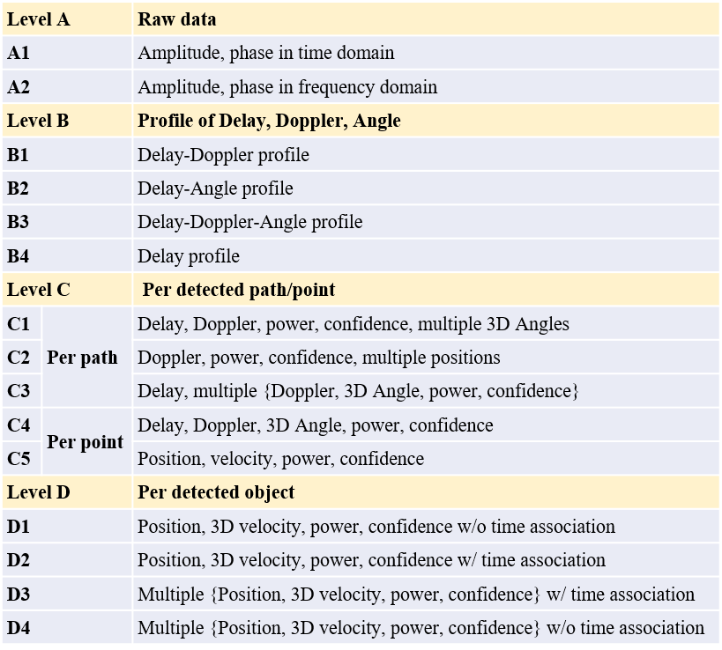
Fig. 3 Different measurement levels
In RAN1#124bis meeting, the following agreement was captured [5].
Agreement:
- On measurement for ISAC, study at least the following aspects.
  - Measurement definitions/levels for TRP-side measurement, taking the measurement Levels studied in NR ISAC as starting point
  - Measurement definitions/levels for UE-side measurement
  - Impacts of non-ideal factors on measurement
  - Other aspects are not precluded
  - Note: this discussion may or may not mean there is specification impact
In TR 38.765 [7], the study on 5G-A ISAC has identified 4 different measurement levels, from the raw sensing data, to the target identification data, as shown in Fig. 3.
Among the 4 measurement levels, Level A and Level B correspond to full-information reporting, where only limited signal processing is performed. When the value space of sensing measurements is large, this may result in significant reporting overhead. Level C can be regarded as a filtered reporting of Level B. With appropriate filtering rules and parameter selection, it can achieve a trade-off between reporting overhead and retained information, where the degree of this trade-off can be controlled by the network, providing high flexibility. Level D requires further signal processing on Level B/C to identify the presence of sensing targets from the intermediate data. This corresponds to the final information required for sensing, which can be directly used for sensing services and results in the lowest reporting overhead. However, it imposes higher signal processing capability requirements on the reporting entity and cannot support multi-point cooperative sensing.
For UE-side measurements, considering that the reports need to be transmitted over the air interface, the reporting overhead should not be excessive. In addition, compared with aNB, UE typically has less signal processing capability. Therefore, Level C can be considered as starting point for UE-side measurement in 6G.
Proposal 8: Level C can be considered as starting point for UE-side measurement in 6G.

Measurement report
In RAN1#124bis meeting, the following agreement was captured [5].
Agreement:
- On measurement report for ISAC, study impacts from at least the following aspects from RAN1 perspective
  - Measurement reporting mechanism
    - E.g., Periodic, semi-persistent, aperiodic, event-triggered report as starting point
    - Reporting signaling e.g., L1, L2, higher layer, etc.
  - Other aspects are not precluded
  - The study may require cross-WG coordination.
Here we discuss the measurement reporting mechanism. For the six sensing modes in Section 2, some require UE-side measurement reporting, e.g. the TRP-UE bistatic mode. Such reports will consume scarce air interface resources. Based on the experience of 5G system design, communication-related measurements, such as CQI and PMI, are associated with well-defined reporting rules to minimize the impact of reporting on uplink capacity and UE power consumption. Sensing measurement reporting would further increase the reporting load and impose additional computational burden on the CPU of UE. Therefore, it is necessary to study reporting rules for sensing measurements, and the following points could be considered:
- Coordination between reporting of sensing measurement and communication measurement;
- Reporting granularity in delay, doppler, and/or angle domain.
Proposal 9: It is necessary to study reporting rules for sensing measurements, and the following points could be considered:
- Coordination between reporting of sensing measurement and communication measurement;
- Reporting granularity in delay, doppler, and/or angle domain.

Beam management
In ISAC, it is important to study beam management for sensing, since the objectives of communication and sensing are different. During the coordination between communication and sensing, more than one beam pair may need to be maintained.
The objective of communication beam is to maximize the link SNR, while the objective of sensing beam is to cover the region where the expected sensing targets are located. When there is a LOS link between TRP and UE, the communication beam and the sensing beam typically point in different directions, as illustrated in Fig. 4.
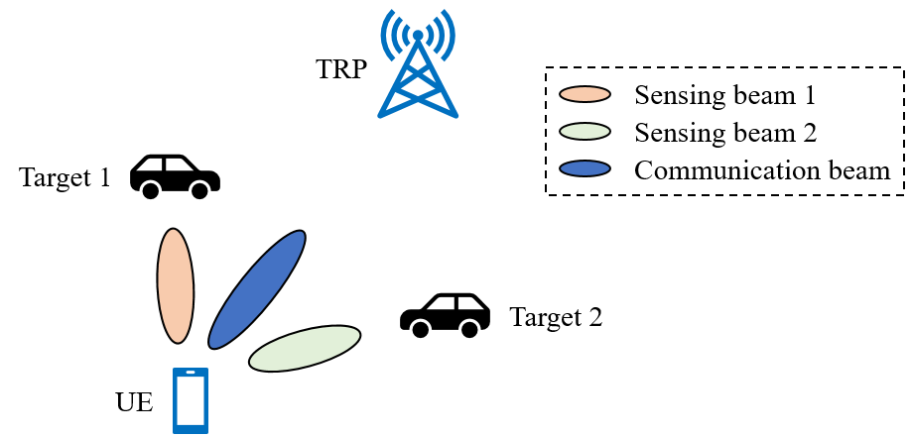
Fig. 4 Sensing and communication beams
On the other hand, sensing targets are typically randomly distributed in the environment and may lie in different directions relative to UE or TRP. To track multiple targets located in different directions simultaneously, multiple sensing beams in different directions may be required.
Therefore, the beam management framework in NR needs to be extended for 6G to allow UE or TRP to activate and maintain multiple beams simultaneously.
Proposal 10: Study extending the NR beam management framework to enable UE or TRP to activate and maintain multiple beams simultaneously.

Conclusions
In this contribution, we provide our views on aspects of integration with communication for ISAC with the following proposals.
Proposal 1: At least six sensing modes of TRP monostatic, TRP-TRP bistatic, TRP-UE bistatic, UE monostatic, UE-UE bistatic, and UE-TRP bistatic could be considered in 6G radio.
Proposal 2: Study sensing measurement procedures, from RAN1 perspective, under different sensing modes and UE capabilities.
Proposal 3: For a given use case, the introduction of enhanced RS for sensing depends on whether the sensing KPI of that use case can be fulfilled by the RS design for communication.
Proposal 4: Support non-uniform RS resource, and it can be considered that non-uniform RS resource is constructed by aggregating multiple uniform RS resources.
Proposal 5: When designing RS resource, the requirements of non-uniform RS aggregation can be considered.
Proposal 6: For UL sensing RS, consider introducing RS bundling and consider UE capability for RS bundling.
Proposal 7: For DL sensing RS, it may be necessary to introduce mechanisms to assist the receiver in recovering phase continuity.
Proposal 8: Level C can be considered as starting point for UE-side measurement in 6G.
Proposal 9: It is necessary to study reporting rules for sensing measurements, and the following points could be considered:
- Coordination between reporting of sensing measurement and communication measurement;
- Reporting granularity in delay, doppler, and/or angle domain.
Proposal 10: Study extending the NR beam management framework to enable UE or TRP to activate and maintain multiple beams simultaneously.

References
- Recommendation ITU-R M.2160-0, Framework and overall objectives of the future development of IMT for 2030 and beyond
- RP-253876, Revised SID: Study on 6G Radio
- TR 23.801-01 V0.4.0 (2026-02)
- TR 22.870 V2.0.0 (2026-03)
- R1-2603284, Session Notes of AI 10.8 (ISAC)
- R1-2602592, Summary #4 on integration with communication for ISAC
- TR 38.765 V1.0.0 (2026-02)

